|  |  |
| --- | --- |
| Object-oriented programming (OOP)  Decryption of a Concept | Abstract  Smart Generation of Architectural Plan  Idea Seminar  Fall 2019 |

**What Is The Main Concept?**

Target: The aim of this concept is that the turtle draws a plan with some points and calculate the number of spaces which have 4 right angles.

**How It Works**

1 – I drew a sample plan. It has some segments and some corners with different angles between two segments.

2- The coordinates of these points should enter to the excel

3- The Excel file must be imported into Python

* Import tools
* Window Setup
* Creating a turtle
* Definition of specific class (class PlanPoint)
* At first step, program reads all of the points with their coordinates
* Next, definition of a dictionary
* Columns separation
* Finding each points from dictionary
* turtle draws dot for p
* turtle draws line form p to q

4- One turtle should connect all of the possible points to each other for creating the sample plan

5- Each space should be analyzed to figure out that if it consists of 4, right angles or not

6- If it is true, count it and if you find another space that has 4 right angles, add the new number to the previous one.

**Things to Notice**

7 – We don’t want to merge some spaces to each other

**Things to Try**

8- In this model we should have 12 closed spaces with 4 right angles in their corner.

**Developing the Model**

9- In the future maybe it can calculate all of the possible spaces which have 4 right angles even with merging of them. In this situation it can work smarter.

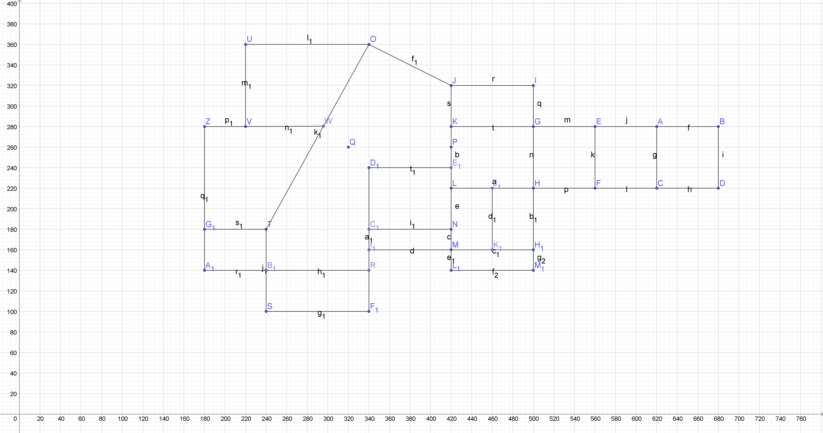

Plan sample

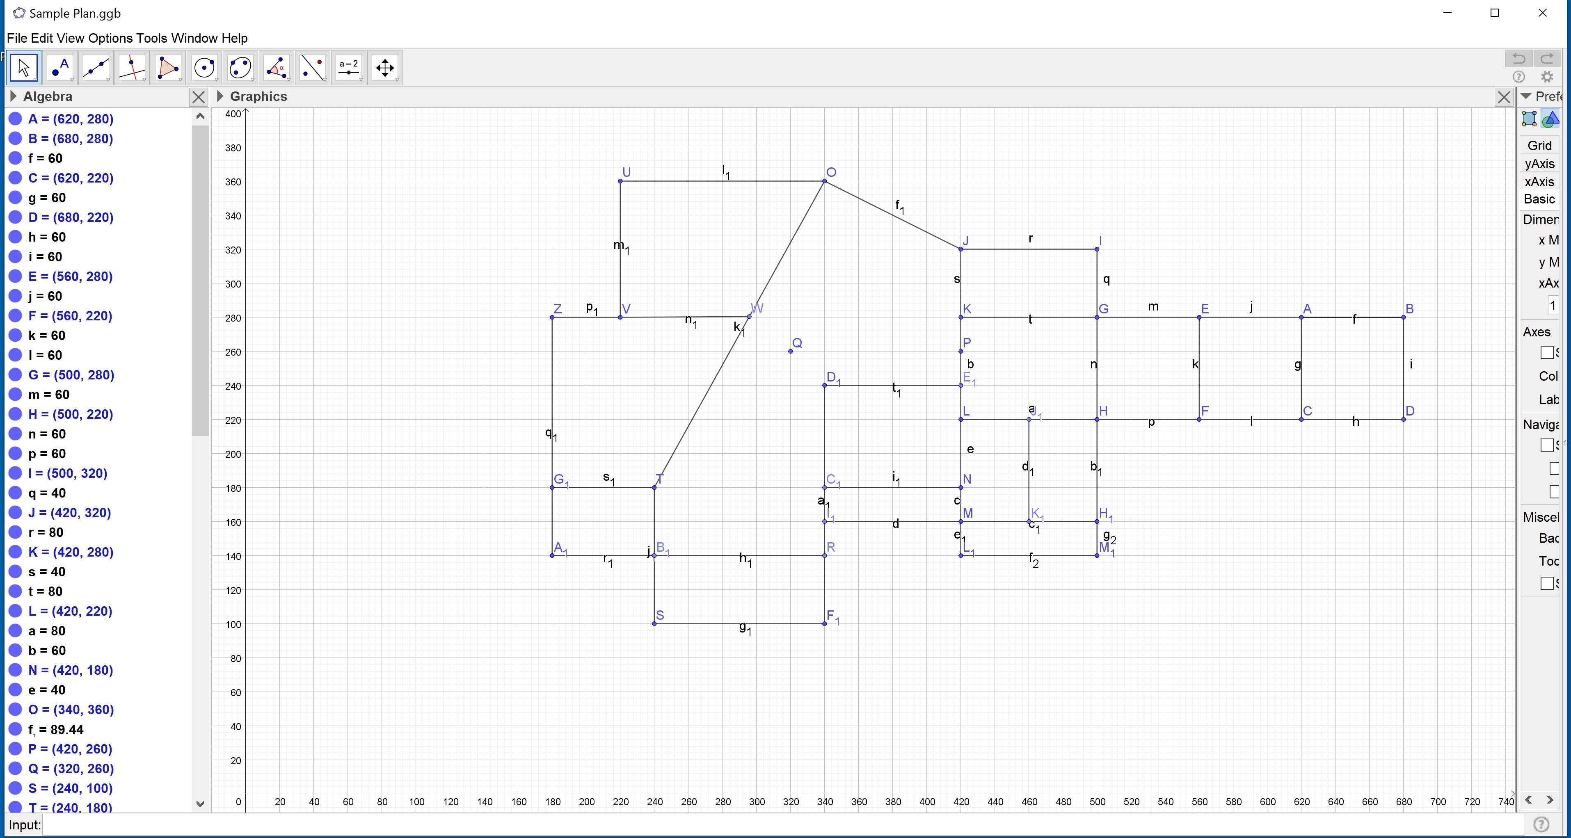

Plan sample with its coordinates